**Module Title: Web Application Development**

**L.U. Introduce PHP Fundamental**

**LO. Effective description of Syntax, Data types, Variables and Operators, Arrays**

|  |
| --- |
|  |

# PHP Syntax

A PHP script is executed on the server, and the plain HTML result is sent back to the browser.

## Basic PHP Syntax

A PHP script can be placed anywhere in the document.

A PHP script starts with **<?php** and ends with **?>**:

<?php  
// PHP code goes here  
?>

The default file extension for PHP files is ".php".

A PHP file normally contains HTML tags, and some PHP scripting code.

Below, we have an example of a simple PHP file, with a PHP script that uses a built-in PHP function "echo" to output the text "Hello World!" on a web page:

### Example

<!DOCTYPE html>  
<html>  
<body>  
  
<h1>My first PHP page</h1>  
  
<?php  
echo "Hello World!";  
?>  
  
</body>  
</html>

**Note:** PHP statements end with a semicolon (;).

## Comments in PHP

A comment in PHP code is a line that is not read/executed as part of the program. Its only purpose is to be read by someone who is looking at the code.

Comments can be used to:

* Let others understand what you are doing
* Remind yourself of what you did - Most programmers have experienced coming back to their own work a year or two later and having to re-figure out what they did. Comments can remind you of what you were thinking when you wrote the code

PHP supports several ways of commenting:

### Example

<!DOCTYPE html>  
<html>  
<body>  
  
<?php  
// This is a single-line comment  
  
# This is also a single-line comment  
  
/*  
This is a multiple-lines comment block  
that spans over multiple  
lines  
*/  
  
// You can also use comments to leave out parts of a code line  
$x = 5 /* + 15 */ + 5;  
echo $x;  
?>  
  
</body>  
</html>

**Module Title: Web Application Development**

**L.U. Introduce PHP Fundamental**

**LO. Effective description of Syntax, Data types, Variables and Operators, Arrays**

|  |
| --- |
|  |

**PHP Constants**

A constant is an identifier (name) for a simple value. The value cannot be changed during the script.

A valid constant name starts with a letter or underscore (no $ sign before the constant name).

**Note:** Unlike variables, constants are automatically global across the entire script.

Create a PHP Constant

To create a constant, use the define() function.

Syntax

define(*name*, *value*, *case-insensitive*)

Parameters:

* *name*: Specifies the name of the constant
* *value*: Specifies the value of the constant
* *case-insensitive*: Specifies whether the constant name should be case-insensitive. Default is false

The example below creates a constant with a **case-sensitive** name:

Example

<?php  
define("GREETING", "Welcome to W3Schools.com!");  
echo GREETING;  
?>

**PHP Operators**

Operators are used to perform operations on variables and values.

PHP divides the operators in the following groups:

* Arithmetic operators
* Assignment operators
* Comparison operators
* Increment/Decrement operators
* Logical operators
* String operators
* Array operators

**PHP Arithmetic Operators**

The PHP arithmetic operators are used with numeric values to perform common arithmetical operations, such as addition, subtraction, multiplication etc.

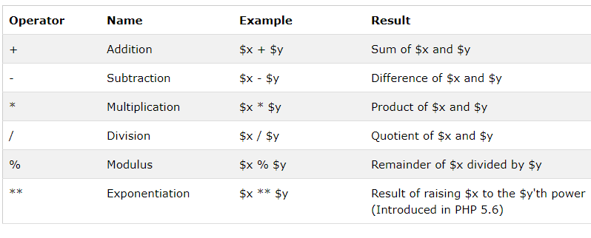

## PHP Assignment Operators

The PHP assignment operators are used with numeric values to write a value to a variable.

The basic assignment operator in PHP is "=". It means that the left operand gets set to the value of the assignment expression on the right.

## PHP Comparison Operators

The PHP comparison operators are used to compare two values (number or string):

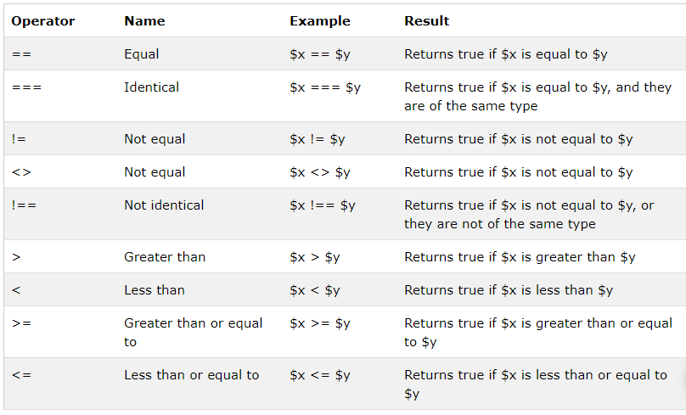

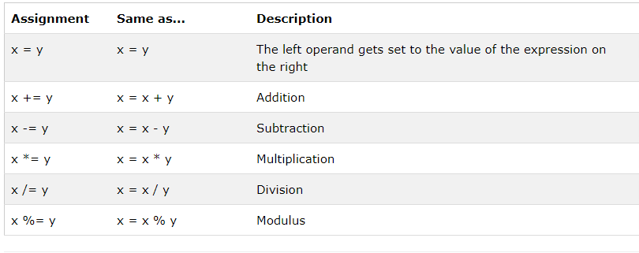

## PHP Increment / Decrement Operators

The PHP increment operators are used to increment a variable's value.

The PHP decrement operators are used to decrement a variable's value.

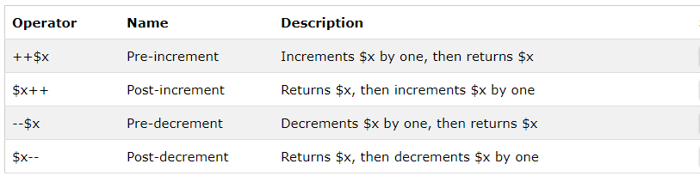

## PHP Logical Operators

The PHP logical operators are used to combine conditional statements.

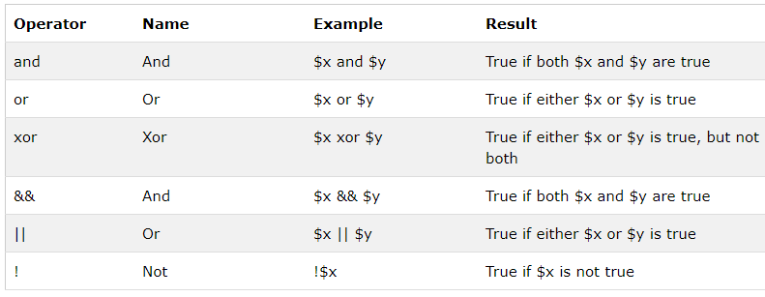

## PHP String Operators

PHP has two operators that are specially designed for strings.

